**Nuachtlitir Uimh 5 Feabhra 2020**



**Gaelscoil & Naíscoil**

**na mBeann**

***Call 028 412 58418 or***

***Email:info@gaelscoilnambeann.***

***kilkeel.ni.sch.uk***

[](https://www.google.co.uk/url?sa=i&url=https://www.pinterest.com/pin/270356783852498717/&psig=AOvVaw0roySfcbtL1zE9RN2_s6GS&ust=1582719833656000&source=images&cd=vfe&ved=0CAIQjRxqFwoTCPjIhv7Y7OcCFQAAAAAdAAAAABAE)

**Gaeilgeoirí na míosa**

Well done to our Gaeilgeoirí na Míosa (Irish Speakers of the Month) for February – Barry Óg, Dáithí, Fionn, Aoife, Caleb C, Leigha and Cady. Maith Sibh!

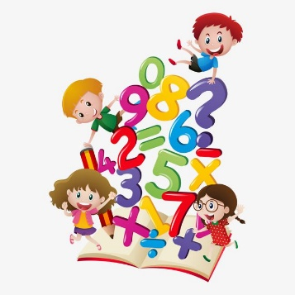**Iarracht San uimhearthacht**

This month we are recognising those children who have made an extra effort with numeracy. Well done to Michaela, Odhran, Wilfred, Oliver, Tia, Patrick and Emma. Ar fheabhas!

**scríbhneoir na míosa**

Comhghairdeas –Congratulations to Lucas, Rueben, Rowan, Faye, Cací, Lara and Chloe for winning this months’ Scríbhneoir na Míosa – writers of the month.

Please see our Facebook Page and Website for photos.

**Bus Scoile**[](https://uk.images.search.yahoo.com/images/view;_ylt=A2KLj9G2CxhUrk0AS0BNBQx.;_ylu=X3oDMTIzZDNzYXZtBHNlYwNzcgRzbGsDaW1nBG9pZAM5NWE5OTI4OWJlZWU5YWNjOWIyODI4YThkZGM0MzBmZQRncG9zAzEyBGl0A2Jpbmc-?back=https://uk.images.search.yahoo.com/search/images?p=clip+art+bus&n=60&ei=UTF-8&vm=r&fr=yfp-t-903&fr2=sb-top-uk.images.search.yahoo.com&tab=organic&ri=12&w=320&h=229&imgurl=1.bp.blogspot.com/_ypalM7eSBEQ/Sx6eF0LleJI/AAAAAAAABeQ/bYO1wktaBgg/s320/School-Bus-Clipart.jpg&rurl=http://clipart-for-free.blogspot.com/2009/12/school-bus-clip-art.html&size=23.7KB&name=Ride+the+school+%3cb%3ebus%3c/b%3e+cliparts&p=clip+art+bus&oid=95a99289beee9acc9b2828a8ddc430fe&fr2=sb-top-uk.images.search.yahoo.com&fr=yfp-t-903&tt=Ride+the+school+%3cb%3ebus%3c/b%3e+cliparts&b=0&ni=128&no=12&ts=&vm=r&tab=organic&sigr=125au7pud&sigb=14ncip8ao&sigi=12ue4nbh1&sigt=113r6io6j&sign=113r6io6j&.crumb=/3qSXzZoyUV&fr=yfp-t-903&fr2=sb-top-uk.images.search.yahoo.com)

**For Health and Safety reasons please do not park in the parking space beside the disabled parking as this needs to be clear for the bus. Children need to be able to get on and off the bus safely. Also, children availing of the bus must be accompanied to and from the bus stops by a responsible adult.**

**Suíomh idirlíon na scoile – school website**

Gaelscoil and Naíscoil na mBeann’s new website is now live. Please download the Schools NI App as it contains up-to-date information regarding Gaelscoil and Naíscoil na mBeann – www.gaelscoilnambeann.com

**scoildrámaíochta**

[](https://www.quaytickets.com/Online/default.asp?doWork::WScontent::loadArticle=Load&BOparam::WScontent::loadArticle::article_id=8DAB9E16-D9BB-4067-BD75-F13CCA5E957F&SessionSecurity::referrer=visitmcr) The Scoildrámaíochta competition which will be held in Newry Town Hall next Friday 6th March. The children will perform Charlie and the Chocolate Factory. We will be providing a bus on the day for students taking part. Parents can come and watch if they wish. Please complete the attached permission slip for your child and return it to school by Monday 2nd March at the latest. No completed permission, No trip!

**Heathy snacks/coats/hair**

[](http://www.google.co.uk/url?sa=i&rct=j&q=&esrc=s&source=images&cd=&ved=2ahUKEwihx4jGjYjmAhX1nVwKHQjOCgIQjRx6BAgBEAQ&url=http://clipart-library.com/ponytail-cliparts.html&psig=AOvVaw0cxwk0dngbLx_DJNQd_aAI&ust=1574865551037136)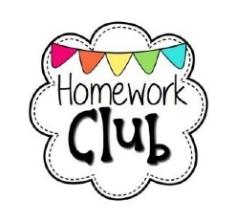Please ensure your child brings a healthy snack and wears a coat to school each day. Please also ensure that if your child has long hair, it is tied up neatly and checked and treated regularly for head lice.

**Extended Schools & homework clubs**

Our Extended Schools Programme is well underway and will continue until the week beginning 9th March 2020. This is a brilliant and free opportunity for your child to improve their Literacy and Numeracy after school on a Monday and Wednesday. Homework clubs are on Tuesdays and Thursdays and cost £1 per session.

**first Confessions**

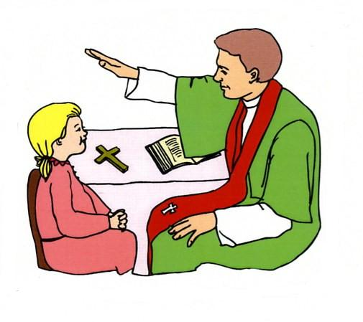If your child in Rang 3 is making his/her First Confession this year, please send a copy of their Baptismal Certificate into school as soon as possible.

**Seachtain na Gaeilge**

To celebrate Seachtain na Gaeilge 2020 and the 10th Anniversary of Gaelscoil na mBeann, there will be plenty of activity going on over the next few weeks at school.

On Tuesday 3rd March, we will have a visit from an Isle of Man Manx Primary School Principal and her Language Development Officer to our school along with the BBC TV cameras. There will be no swimming for Rang 5 on that day and we would ask that all children come to school in FULL SCHOOL UNIFORM. The children have been practising songs and dance for the occasion. Note also that there will be NO PM BUS THAT DAY. Please make alternative arrangements for the collection of your child(ren) from Gaelscoil.

On Thursday 5th March, the Chairman of NMDDC Charlie Casey will visit the Gaelscoil to mark the commencement of our 10th year anniversary celebrations.

**cinema trip for Rang 4&5**

On Thursday 12th March, Rang 4 & 5 have been invited to Omniplex Cinema in Newry to watch a movie and take part in a review writing workshop. Please see the attached permission slip, complete and return to Gaelscoil na mBeann via email. No completed permission, No trip!

**Lá Domhanda leabhair – world book day 2020**

[](https://www.google.co.uk/url?sa=i&url=https://www.activityvillage.co.uk/world-book-day&psig=AOvVaw1cKZwna3_52wBJB2Mogt5m&ust=1582813679864000&source=images&cd=vfe&ved=0CAIQjRxqFwoTCMjsrMu27-cCFQAAAAAdAAAAABAE)This year, Naíscoil and Gaelscoil na mBeann will hold World Book Day on Wednesday 4th March 2020. Children can come to school on that day dressed as a character in their favourite book.

**dataí don díalann**

[](https://www.google.co.uk/url?sa=i&url=http://clipartmag.com/dates-clipart&psig=AOvVaw0AepgXx7q0grfJ6e2EhHf3&ust=1571927946005000&source=images&cd=vfe&ved=0CAIQjRxqFwoTCJCYlonOsuUCFQAAAAAdAAAAABAE)

Manx Visitors 03.03.2020

World Book Day 04.03.2020

Visit from NMDDC 05.03.2020

Féile Scoildramaíochta 06.03.2020

Cinema Trip Rang 4&5 12.03.2020

First Confessions Rang 3 12.03.2020

St Patrick’s Day Break 16 & 17.03.2020

Feis an Dúin 28.03.2020

Rang 1 Nurse Check-ups 30 & 31.03.2020

**Lá na Bpancóg-Pancake day**

To celebrate Pancake Tuesday, Naíscoil and Gaelscoil na mBeann children had a fun day making pancakes. See web page for more photos.

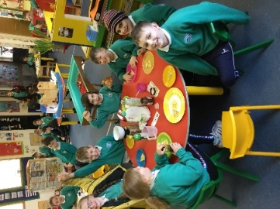

[](https://www.google.co.uk/url?sa=i&url=https://www.pinterest.com/amylynndorshak6/st-patricks-day-clip-art/&psig=AOvVaw1B6DXOAzix8kdt-F9qjjU1&ust=1582813881283000&source=images&cd=vfe&ved=0CAIQjRxqFwoTCLiOtau37-cCFQAAAAAdAAAAABAE)**Lá Glas – Green Day**

To celebrate St Patrick’s Day, we will be holding Lá Glas – Green Day on Friday 13th March 2020 in school. There will be various activities going on in Gaelscoil & Naíscoil throughout the day eg quizzes, ceili, dancing etc. Children should come to school wearing green (non-uniform if they want) and we would ask for £1 donation for Trocaire.

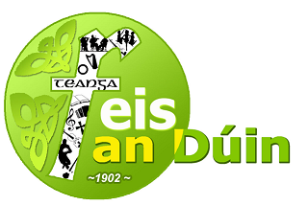

**Feis an dúin**

**Venue: Newcastle Centre**

**Date: Saturday 28th March 2020**

**P1 – P4 10.00 am - 12.30pm**

**P5 – P7 2.00 pm - 3.30 pm**

Please note that there is £2 (non-refundable) entry fee** per competition. Payment must be received by 14th March 2020

The following competitions are open to all Primary schools in the Feis area

Comhrá –Conversation Rang 1-7

Aithriseoireacht – Poetry Rang 1-7

**NB Separate competitions will be held for pupils from Irish - Medium schools at the stated times.**

**Scolireachtaí - Scholarships**

1. 2 Awards of £100 to pupils from Irish-medium schools. (Rang 6/7 only)

**NB**

Late entries will not be accepted under any circumstances

**Crannchur CLG- GAA Schools**

[](https://www.google.co.uk/url?sa=i&rct=j&q=&esrc=s&source=images&cd=&cad=rja&uact=8&ved=2ahUKEwiZz9Ts5K7hAhUCsXEKHTqWC8MQjRx6BAgBEAU&url=https://sites.google.com/a/liscarrollns.org/public/announcements/gaelicfootballforjuniorsseniorsand1stclass?overridemobile%3Dtrue&psig=AOvVaw1aUXSBj_yq3f6ojOzueqgy&ust=1554204418431094)**Coaching Draw 2020**

**DOWN SCHOOLS GAA DRAW 2020**

Each family has been given a book of tickets to sell for the Down GAA Draw 2020. The money raised will cover the cost of the Gaelic games coaching in our school and add to school funds and as you will see, the prizes are brilliant. Cost is £2 per ticket or 3 for £5. Tickets should be returned to Gaelscoil on or before Thursday 19th March. Good luck to everyone in the draw!

[](http://www.google.co.uk/url?sa=i&rct=j&q=&esrc=s&source=images&cd=&cad=rja&uact=8&ved=2ahUKEwj9p9jH24TZAhUnKcAKHZ8bBYMQjRx6BAgAEAY&url=http://www.google.co.uk/url?sa%3Di%26rct%3Dj%26q%3D%26esrc%3Ds%26source%3Dimages%26cd%3D%26ved%3D%26url%3Dhttp://moziru.com/explore/Question%20Mark%20clipart%20questions%20and%20answer/%26psig%3DAOvVaw1yoGAjNDmGDrh85QSNlBfc%26ust%3D1517574451214110&psig=AOvVaw1yoGAjNDmGDrh85QSNlBfc&ust=1517574451214110)**Queries *Please remember that if you have any queries/concerns regarding your child or any other matter, you can contact the school at any time. I am here to assist in any way I can. Call 028 412 58418 or Email info@gaelscoilnambeann.kilkeel.ni.sch.uk***