Paper Owl Films  www.paperowlfilms.com | 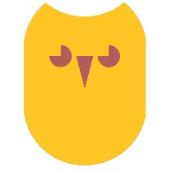
REGISTRATION OF INTEREST IN ‘Lí Ban’
Please complete this form to register your interest in auditioning for a role in the animated film ‘Lí Ban’.

We are committed to providing a safe, comfortable space for our voice actors, and so we ask that all applicants are made aware of the following before considering auditioning for a role in ‘Lí Ban’. It’s important that candidates understand what is involved in the work – and think about whether it is something that they would enjoy and benefit from doing.

- Lí Ban will be recorded in Belfast
- Accompanying the actor during recording will be a producer, director and two sound engineers as well as a parent or chaperone.
- The chosen candidate will be required to record the dialogue in both English and Irish.

ROLE AUDITIONING FOR:
NAME:
DATE OF BIRTH
PARENT/GUARDIAN NAME
EMAIL
PHONE NUMBER
ADDRESS

If successful, would there any steps that Paper Owl Films may take in order to make you or your child feel more comfortable during the recording process?

Is there additional information you would like to share about you/your child?

